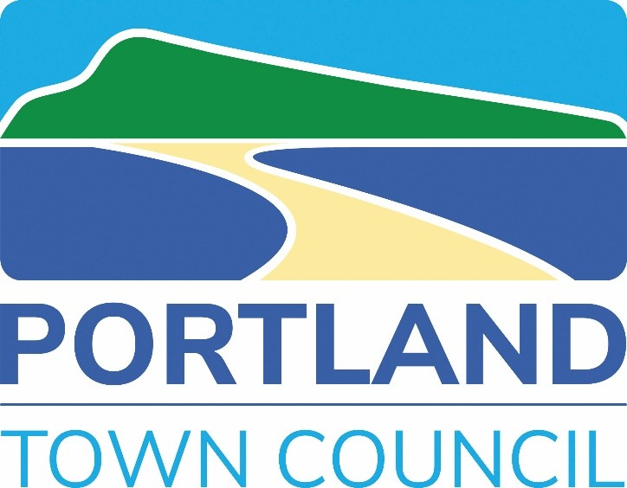

Portland Town Council
Grant Application Form

Please read through the Portland Town Council (PTC) Grant Award Guidance Notes BEFORE completing this application form. All grant forms can be found on the Town Council website:
https://portlandtowncouncil.gov.uk/council/accounts/grants

Please download this form to your computer and either:

- Complete it electronically, save a copy and email it back as an attachment, OR
- Clearly write in the text boxes, scan or photograph your completed copy and:
- Email it back as an attachment, OR
- Post it or drop it into:
Portland Town Council
Portland Community Venue
Three Yards Close
Portland
Dorset
DT5 IJN

Help and Information
If you require any assistance in completing this form or if you have any queries, please contact us at:
Portland Town Council, Portland Community Venue, Three Yards Close, Portland, Dorset, DT5 IJN

Telephone: 01305 821638 E-mail finance@portlandtowncouncil.gov.uk

Key date

Applications for Portland Town Council Grant Awards close on 31st January 2027 or sooner if grant funds have already been allocated.

Correspondence

All applicants will be notified of the Town Council’s Grant Award decision
NB - this may be a deferment decision if further information is required.

APPLICATION FORM FOR PORTLAND TOWN COUNCIL GRANT AWARD

Please refer to the Grant Award Guidance Notes for details about each of the following sections
Ref:
For Office use only
- CONTACT AND ADMINISTRATIVE DETAILS
Items noted * MUST be completed

Name of group / organisation*
Contact Name*
Contact (postal) address
Position/ role in group/ organisation*
Contact telephone number*
Contact e-mail address*

Group/ organisation social media account/ website details (if applicable)

Is your group/ organisation newly formed? (less than 1 year) | Yes  No | How long has your group been operating?
Briefly details the general aims, objectives and/ or activities of your organisation (up to 150 words or attach your mission statement etc.)

Grant funds must be paid into a group/organisation/charity bank account that must be open before submitting your grant application. If successful, your grant will be paid by BACS payment directly into your group / organisations bank account. Confirmation of bank details (or appropriate payment method) will be confirmed at a later point.

- PROJECT/ ACTIVITY/ EVENT INFORMATION
What is the amount of grant requested from Portland Town Council? | (If applicable to grant funding amount being requested, see also TOTAL cost of project/activity/ event in Section 3 below)  £
What is the name/ title of the project/ activity/ event?

Why are you applying for this funding? (up to 300 words or attach your outline project brief etc.)
Sources of other funding including details of other grants or awards applied for or gained in relation to stated project/activity/event.
How would a PTC Grant Award make a difference to your group/ organisation and its members?
How will the people and communities of Portland benefit from this project/ activity/ event? | Please provide details of the types of beneficiaries this funding will benefit e.g. gender; age group; socio-economic background; specific geographical areas; support of specific groups and networks etc.
Approximately how many people usually attend your sessions and approximately how many of these are Portland residents?
Future sustainable plans – provide details on your plans to financially support future years.
Does your group have a safeguarding policy in place if applicable? | Yes  N/A | If yes, what was the date this was last reviewed?
Are all staff/volunteers working with children and vulnerable adults DBS checked? | Yes  N/A
What is the timing of this project/ activity/ event? | Please provide details of when it is planned to start and finish (NB - all grants awarded in must be SPENT within 1 year of the grant award date)

- FINANCIAL AND ORGANISATIONAL INFORMATION (Part 1)
Does your group/ organisation have a voluntary management committee / steering group? | Yes  No | If Yes, how many people are on it?
Have you received a grant from this Council previously? | Yes  No | If Yes, for how much and what was it for?
What is the TOTAL cost of the project/ activity/ event you are requesting funding for? | £
What will happen if you get less funding than you asked for? Will all/ part of the project/ activity/ event go ahead? | Please tell us what could be achieved if you only receive part funding:

- FINANCIAL AND ORGANISATIONAL INFORMATION (Part 2)
Does your group/ organisation have A written constitution? | Yes  No | If Yes, please attach a copy to your application.
What is your charity number or other community group registration? | (Please insert N/A if not applicable):

Please provide a FULL breakdown of the project/ activity/ events costs and how they will be funded, including match funding or other financial/ in-kind contribution (Continue on a separate page if required)
Item/ Activity | Description of financial and/ or in-kind contribution | Source of funding / contribution
TOTAL COST | £

- FINANCIAL AND ORGANISATIONAL INFORMATION (Part 3)
Does your group/ organisation record Committee or Board Minutes? | Yes  No | If Yes, please provide the last 12 months of Minutes (Attach copies to your application)
Does your group/ organisation have an annual record of accounts or financial reports? | Yes  No | If Yes, please provide the last 2 years of annual accounts/ financial reports (Attach copies to your application)  If No, please provide your cash flow forecast for next year with an explanation of the sources of funding/ income (Attach copies to your application)

- DECLARATION
- I confirm that I have read the Portland Town Council Grant Award Guidance Notes and that I am aware of the Terms and Conditions attached to applying for and receiving a Portland Town Council Grant Award. Any unspent funds will be required to be paid back to the town council.

Tick here
I confirm:
- That the information provided in this application is a fair and accurate description of our group/ organisation and our proposed project/ activity/ event, and that the details I have provided are true and correct to the best of my knowledge.
- I am authorised to apply for funding on behalf of the group. I confirm that our group/ organisation agrees to abide by the Terms and Conditions of the Portland Town Council Grants Award process and any other conditions which Portland Town Council imposes at the time of awarding the grant.
- That our group/ organisation agrees to acknowledge the funding provided by Portland Town Council on our website (an electronic logo will be provided should you be successful), on any letter headed paper and other relevant paperwork.
- If your grant is approved, once payment has been made, we will be in touch with a short feedback form for you to complete, this helps us assess the impact of your Community Grant and how it has benefitted your Group/Organisation.
Tick here
I confirm:
Date:
Signature:

Print name:

Position in Organisation:

APPLICATION CHECKLIST

Have you provided ALL the required contact details?
Does your application clearly explain how Portland residents and communities would benefit from any grant awarded to your group/ organisation?
Does your project/ activity/ event fit within the grant award spend timeline?
Have you attached the required information for the community grant?
  - Section 4
    - Written constitution
  - Section 5
    - Committee or Board Minutes
    - Annual record of accounts or financial reports
    - Other grants or contributions
    - Cash flow forecast
Have you signed the Declaration

Please submit your completed Grant Application form and any supporting documentation to:
finance@portlandtowncouncil.gov.uk

OR

Post or drop off your Grant Application form and any supporting documentation to:
Portland Town Council
Portland Community Venue
Three Yards Close
Portland
Dorset
DT5 IJN

Further information about Portland Town Council and its grant making is available from:
https://portlandtowncouncil.gov.uk/council/accounts/grants

Portland Town Council looks forward to receiving your application!

